Arduino 入门到精通 例程17
这次我们进行的实验是使用arduino驱动一块共阴四位数码管。驱动数码管限流电阻肯定是必不可少的，限流电阻有两种接法，一种是在d1-d4阳极接，总共接4颗。这种接法好处是需求电阻比较少，但是会产生每一位上显示不同数字亮度会不一样，1最亮，8最暗。另外一种接法就是在其他8个引脚上接，这种接法亮度显示均匀，但是用电阻较多。本次实验使用8颗220Ω电阻（因为没有100Ω电阻，所以使用220Ω的代替，100欧姆亮度会比较高）。
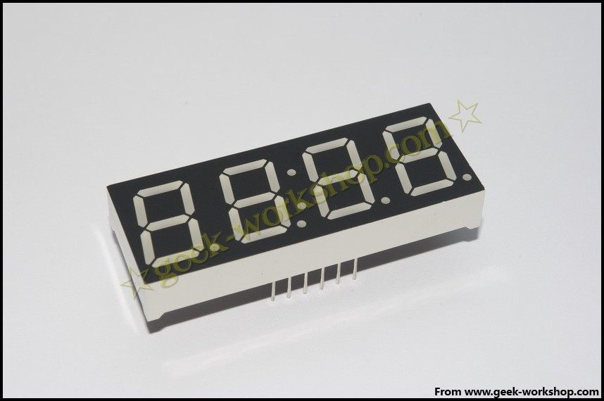
4位数码管总共有12个引脚，小数点朝下正放在面前时，左下角为1,其他管脚顺序为逆时针旋转。左上角为最大的12号管脚。
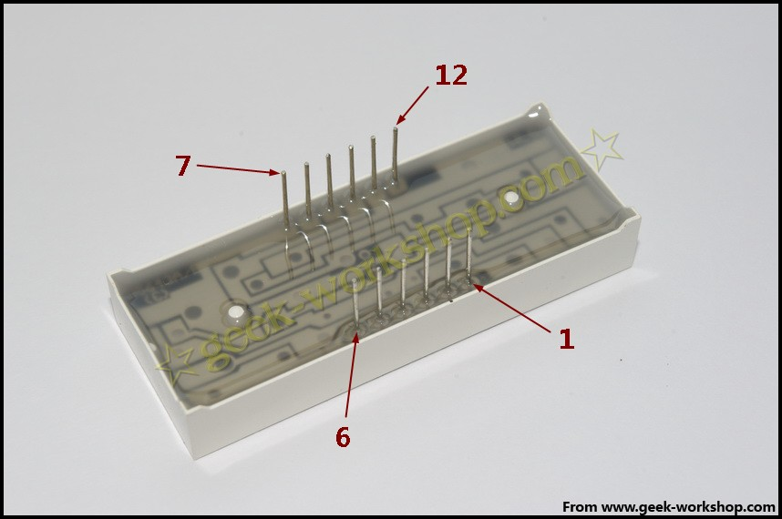
下图为数码管的说明手册
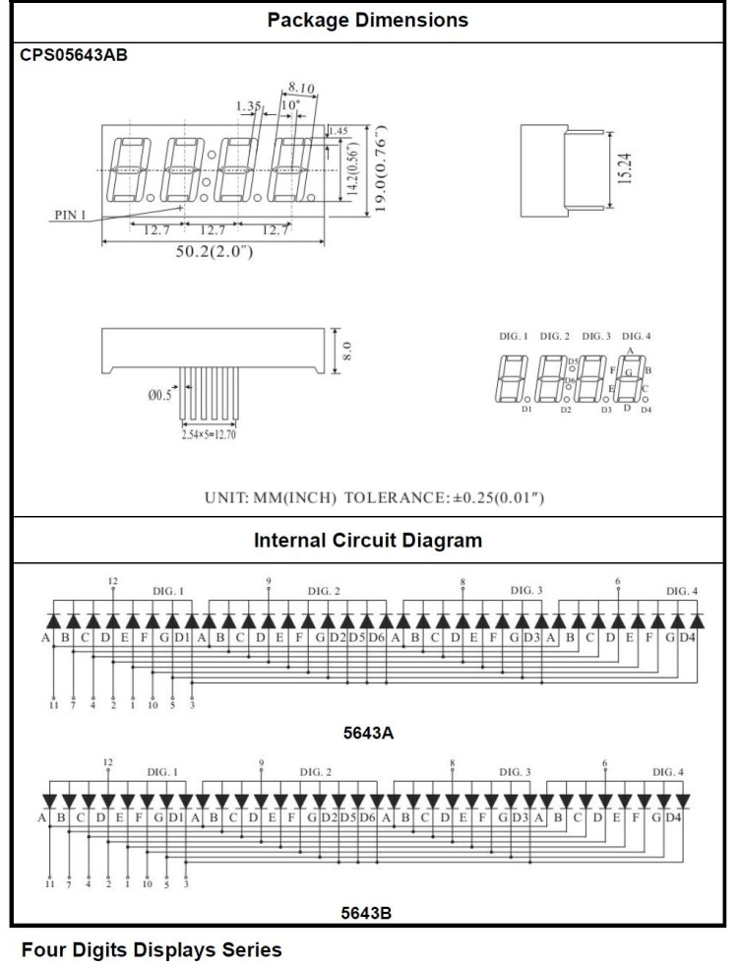

下面是硬件连接图
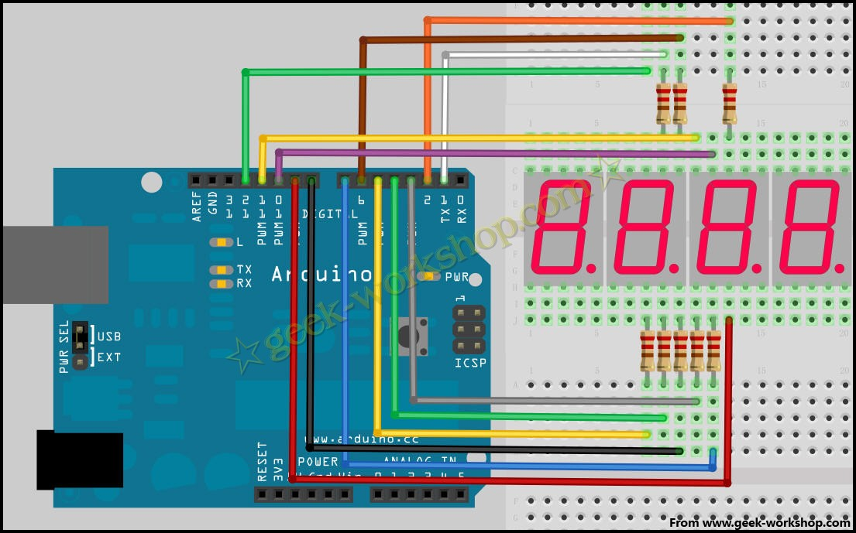
下面是程序；

//显示1234
//设置阴极接口
int a = 1;
int b = 2;
int c = 3;
int d = 4;
int e = 5;
int f = 6;
int g = 7;
int dp = 8;
//设置阳极接口
int d4 = 9;
int d3 = 10;
int d2 = 11;
int d1 = 12;
//设置变量
long n = 1230;
int x = 100;
int del = 55; //此处数值对时钟进行微调

void setup()
{
pinMode(d1, OUTPUT);
pinMode(d2, OUTPUT);
pinMode(d3, OUTPUT);
pinMode(d4, OUTPUT);
pinMode(a, OUTPUT);
pinMode(b, OUTPUT);
pinMode(c, OUTPUT);
pinMode(d, OUTPUT);
pinMode(e, OUTPUT);
pinMode(f, OUTPUT);
pinMode(g, OUTPUT);
pinMode(dp, OUTPUT);
}
/////////////////////////////////////////////////////////////
void loop()
{
Display(1, 1);
Display(2, 2);
Display(3, 3);
Display(4, 4);

}
///////////////////////////////////////////////////////////////
void WeiXuan(unsigned char n)//
{
switch(n)
{
case 1:
digitalWrite(d1,LOW);
digitalWrite(d2, HIGH);
digitalWrite(d3, HIGH);
digitalWrite(d4, HIGH);
break;
case 2:
digitalWrite(d1, HIGH);
digitalWrite(d2, LOW);
digitalWrite(d3, HIGH);
digitalWrite(d4, HIGH);
break;
case 3:
digitalWrite(d1,HIGH);
digitalWrite(d2, HIGH);
digitalWrite(d3, LOW);
digitalWrite(d4, HIGH);
break;
case 4:
digitalWrite(d1, HIGH);
digitalWrite(d2, HIGH);
digitalWrite(d3, HIGH);
digitalWrite(d4, LOW);
break;
default :
digitalWrite(d1, HIGH);
digitalWrite(d2, HIGH);
digitalWrite(d3, HIGH);
digitalWrite(d4, HIGH);
break;
}
}
void Num_0()
{
digitalWrite(a, HIGH);
digitalWrite(b, HIGH);
digitalWrite(c, HIGH);
digitalWrite(d, HIGH);
digitalWrite(e, HIGH);
digitalWrite(f, HIGH);
digitalWrite(g, LOW);
digitalWrite(dp,LOW);
}
void Num_1()
{
digitalWrite(a, LOW);
digitalWrite(b, HIGH);
digitalWrite(c, HIGH);
digitalWrite(d, LOW);
digitalWrite(e, LOW);
digitalWrite(f, LOW);
digitalWrite(g, LOW);
digitalWrite(dp,LOW);
}
void Num_2()
{
digitalWrite(a, HIGH);
digitalWrite(b, HIGH);
digitalWrite(c, LOW);
digitalWrite(d, HIGH);
digitalWrite(e, HIGH);
digitalWrite(f, LOW);
digitalWrite(g, HIGH);
digitalWrite(dp,LOW);
}
void Num_3()
{
digitalWrite(a, HIGH);
digitalWrite(b, HIGH);
digitalWrite(c, HIGH);
digitalWrite(d, HIGH);
digitalWrite(e, LOW);
digitalWrite(f, LOW);
digitalWrite(g, HIGH);
digitalWrite(dp,LOW);
}
void Num_4()
{
digitalWrite(a, LOW);
digitalWrite(b, HIGH);
digitalWrite(c, HIGH);
digitalWrite(d, LOW);
digitalWrite(e, LOW);
digitalWrite(f, HIGH);
digitalWrite(g, HIGH);
digitalWrite(dp,LOW);
}
void Num_5()
{
digitalWrite(a, HIGH);
digitalWrite(b, LOW);
digitalWrite(c, HIGH);
digitalWrite(d, HIGH);
digitalWrite(e, LOW);
digitalWrite(f, HIGH);
digitalWrite(g, HIGH);
digitalWrite(dp,LOW);
}
void Num_6()
{
digitalWrite(a, HIGH);
digitalWrite(b, LOW);
digitalWrite(c, HIGH);
digitalWrite(d, HIGH);
digitalWrite(e, HIGH);
digitalWrite(f, HIGH);
digitalWrite(g, HIGH);
digitalWrite(dp,LOW);
}
void Num_7()
{
digitalWrite(a, HIGH);
digitalWrite(b, HIGH);
digitalWrite(c, HIGH);
digitalWrite(d, LOW);
digitalWrite(e, LOW);
digitalWrite(f, LOW);
digitalWrite(g, LOW);
digitalWrite(dp,LOW);
}
void Num_8()
{
digitalWrite(a, HIGH);
digitalWrite(b, HIGH);
digitalWrite(c, HIGH);
digitalWrite(d, HIGH);
digitalWrite(e, HIGH);
digitalWrite(f, HIGH);
digitalWrite(g, HIGH);
digitalWrite(dp,LOW);
}
void Num_9()
{
digitalWrite(a, HIGH);
digitalWrite(b, HIGH);
digitalWrite(c, HIGH);
digitalWrite(d, HIGH);
digitalWrite(e, LOW);
digitalWrite(f, HIGH);
digitalWrite(g, HIGH);
digitalWrite(dp,LOW);
}
void Clear() //清屏
{
digitalWrite(a, LOW);
digitalWrite(b, LOW);
digitalWrite(c, LOW);
digitalWrite(d, LOW);
digitalWrite(e, LOW);
digitalWrite(f, LOW);
digitalWrite(g, LOW);
digitalWrite(dp,LOW);
}
void pickNumber(unsigned char n)//选数
{
switch(n)
{
case 0:Num_0();
break;
case 1:Num_1();
break;
case 2:Num_2();
break;
case 3:Num_3();
break;
case 4:Num_4();
break;
case 5:Num_5();
break;
case 6:Num_6();
break;
case 7:Num_7();
break;
case 8:Num_8();
break;
case 9:Num_9();
break;
default:Clear();
break;
}
}
void Display(unsigned char x, unsigned char Number)//显示x为坐标，Number为数字
{
WeiXuan(x);
pickNumber(Number);
delay(1);
Clear() ; //消影
}

把下面代码复制下载到控制板中，看看效果图。
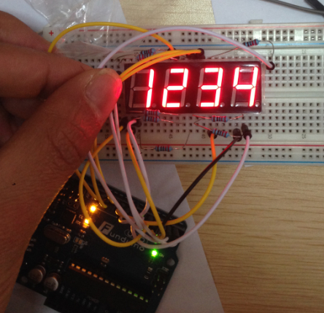

实验结果为数码管显示1234 ，
注意：连接的时候需要耐心，认真，不要连错任何线，当出现乱码时，要先检查线路。
谢谢!

